Joshua Pollock

CS 200 Homework 8

5 April 2017

1.

|  |  |
| --- | --- |
| $t0 | 5000 |
| $t1 | 3000 |
| $t2 | 0 |
| $t3 | 1001004 |
| $t4 | 1 |
| $t5 | 40024 |
| $t6 | 40090 |
| $t7 | 40064 |

|  |  |  |  |
| --- | --- | --- | --- |
| 00005000 | 00003000 | 00002000 |  |
| 00000001 | 00000000 | 00005000 | 00008000 |

2.

a.

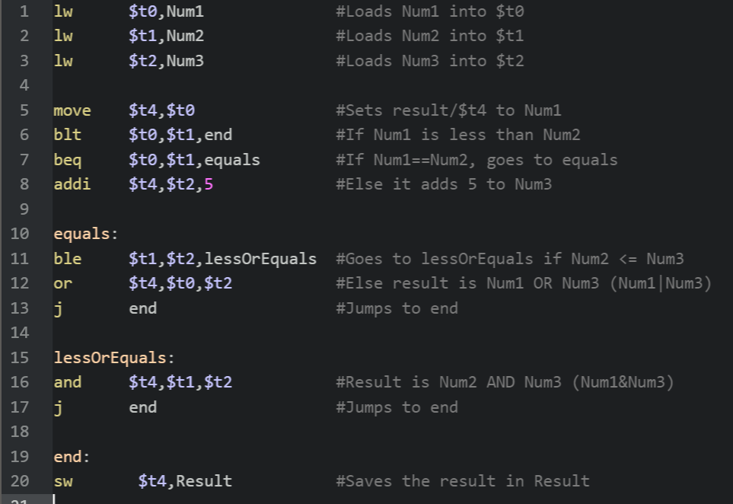

b.

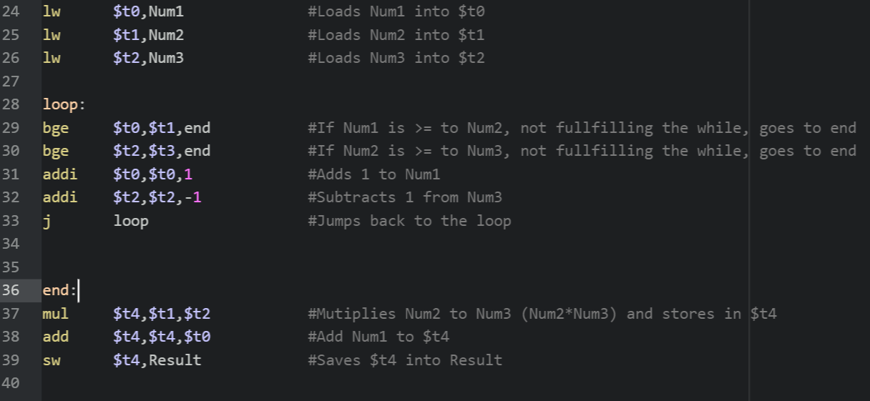

Plain Text Form:

a.

lw $t0,Num1 #Loads Num1 into $t0

lw $t1,Num2 #Loads Num2 into $t1

lw $t2,Num3 #Loads Num3 into $t2

move $t4,$t0 #Sets result/$t4 to Num1

blt $t0,$t1,end #If Num1 is less than Num2

beq $t0,$t1,equals #If Num1==Num2, goes to equals

addi $t4,$t2,5 #Else it adds 5 to Num3

equals:

ble $t1,$t2,lessOrEquals #Goes to lessOrEquals if Num2 <= Num3

or $t4,$t0,$t2 #Else result is Num1 OR Num3 (Num1|Num3)

j end #Jumps to end

lessOrEquals:

and $t4,$t1,$t2 #Result is Num2 AND Num3 (Num1&Num3)

j end #Jumps to end

end:

sw $t4,Result #Saves the result in Result

b.

lw $t0,Num1 #Loads Num1 into $t0

lw $t1,Num2 #Loads Num2 into $t1

lw $t2,Num3 #Loads Num3 into $t2

loop:

bge $t0,$t1,end #If Num1 is >= to Num2, not fullfilling the while, goes to end

bge $t2,$t3,end #If Num2 is >= to Num3, not fullfilling the while, goes to end

addi $t0,$t0,1 #Adds 1 to Num1

addi $t2,$t2,-1 #Subtracts 1 from Num3

j loop #Jumps back to the loop

end:

mul $t4,$t1,$t2 #Mutiplies Num2 to Num3 (Num2*Num3) and stores in $t4

add $t4,$t4,$t0 #Add Num1 to $t4

sw $t4,Result #Saves $t4 into Result